1. Incident Name  St. Elsewhere COVID-19 | 2. Operational Period (# 1 )  DATE: FROM: 19 – AUG - 20120 TO: 20-AUG-2020  TIME: FROM: 0800 TO: 0800. (NORMALLY THIS IS A SHORT TIMEFRAME FOR THE OPERATIONAL PERIOD, BUT WITH A PANDEMIC/EPIDEMIC IT IS A MUCH LONGER EXPECTED TIMEFRAME SO 24 HOURS, OR EVEN LONGER, ARE EXPECTED)
3. Situation Summary (for briefings or transfer of command)
The first confirmed case of COVID-19 has just been confirmed on a patient in the ICU. The patient has been under Airborne Isolation since admission with proper PPE being used by staff.

(THIS IS WHERE YOU PUT A SHORT OVERVIEW OF WHAT IS GOING ON. IT DOESN’T NEED TO INCLUDE EVERYTHING AND WE KNOW THAT THE INFORMATION WILL CHANGE, YOU DON’T HAVE TO UPDATE THIS ONE, IT IS EXPECTED TO CHANGE)

4. Health and Safety Briefing Identify potential incident health and safety hazards and implement necessary measures (remove hazard, provide personal protective equipment, warn people of the hazard) to protect responders from those hazards. (Summary of HICS 215A)

See HICS 215A Safety Analysis.

(YOU DON’T HAVE TO REWRITE IT. YOU CAN JUST REFER TO YOUR HICS 215A)

5. Map / Sketch (Attach sketch showing the total area of operations, the incident site/area, impacted and threatened areas,
and/or other graphics depicting situational status and resource assignment, as needed.)
See Attached
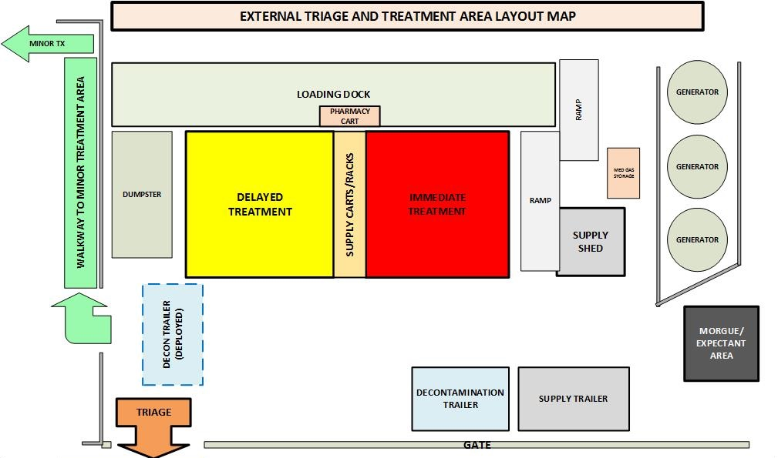 (INCLUDE MAPS OF WHAT ARE HELPFUL HERE SUCH AS TRIAGE AREAS, OR TREATMENT AREAS, ETC.)

6. Current Hospital Incident Management Team (fill in additional positions as appropriate)
Liaison Officer
Elvis Presley
Safety Officer
Sandra Day O’Connor
Public Information Officer
Walt Disney

Incident Commander(s)
Louisa May Alcott

Medical-Technical Specialists
Abraham Lincoln
Planning
Section Chief
Janis Joplin
Operations
Section Chief
Alexander Hamilton
Finance / Administration
Section Chief
Bill Gates
Logistics
Section Chief
Thomas Edison

Staging Manager
Queen Elizabeth II
Time Unit Leader
Indira Gandhi
Service Branch Director
Ella Fitzgerald
Resources Unit Leader Harry Styles

Procurement Unit Leader
Albert Einstein
Support Branch Director
Martha Stewart
Situation Unit Leader
Amelia Earhart
Medical Care Branch Director
Jesse Owens

Patient Family Assistance Branch Director Melinda Gates

Business Continuity Branch Director Wolfgang Puck

HazMat Branch Director Jimi Hendrix

Cost Unit Leader Beyoncé

Compensation/ Claims Unit Leader Jack Sparrow

Demobilization Unit Leader Bob the Builder

Documentation Unit Leader
Alex Trebek
Security Branch Director GI Joe

Infrastructure Branch Director
Clara Barton
7. Incident Objectives

- Identify extent of loss of water and consider evacuation
- Maintain patient care capabilities
- Minimize impact on hospital operations and clinical services
- Communicate the situation status to patients, staff, Medical and Health Operational Area Coordinator (MHOAC) and the public

8. Summary of Current and Planned Actions
Time | actions
0805 | Activated Emergency Operations Plan and the Hospital Command Center
0810 | Activated Command Staff and General Staff Chief positions (see box 3)
0820 | Held Incident Briefing with Command and General staffP

9. Summary of Resources Requested and Assigned
Resource | Date / Time  Ordered | ETA | Date / Time Arrived | Notes  (location / assignment / status)
10. Prepared by Incident Commander PRINT NAME: Louisa May Alcott SIGNATURE: Louisa May Alcott
BRIEFING DATE/TIME: _______0820__________________________________________ FACILITY: St. Elsewhere Hospital

purpose: The HICS 201 – Incident Briefing provides the Incident Commander and the Hospital Incident Management Team (HIMT) with basic information regarding the incident, current situation, and the resources allocated to the response.

ORIGINATION: Prepared by the Incident Commander for presentation to the staff or later to the incoming Incident Commander along with a detailed oral briefing.

COPIES TO: Duplicate and distribute before the initial briefing of the Command and General Staff or
other responders as appropriate. All completed original forms must be given to the Documentation Unit Leader.

Notes: If additional pages are needed for any form page, use a blank HICS 201 and repaginate as needed. Additions may be made to the form to meet the organization’s needs.

NUMBER | TITLE | INSTRUCTIONS
1 | Incident Name | Enter the name assigned to the incident.
2 | Operational Period | Enter the start date (m/d/y) and time (24-hour clock) and end date and time for the operational period to which the form applies.
3 | Situation Summary | Concise statement of the status and information regarding the current situation.
4 | Health and Safety Briefing | Enter the summary of health and safety issues and instructions.
5 | Map / Sketch | Attach as necessary: floor plans, maps, sketches of impacted area, or response diagrams. North should be at the top of the page unless noted otherwise.
6 | Current Hospital Incident Management Team | Enter the names of the individuals assigned to each position directly onto the Hospital Incident Management Team (HIMT) chart. If Unified Command is being used, split the Incident Commander box and indicate agency for each of the Incident Commanders listed.
7 | Incident Objectives | Enter the objectives used for the incident.
8 | Summary of Current and Planned Actions | Enter the current and planned actions and time (24-hour clock) they may or did occur. If additional pages are needed, use a blank sheet or another HICS 201 (page 3), and adjust page numbers accordingly.
9 | Summary of Resources Requested and Assigned | Enter information about the resources allocated to the incident. If additional pages are needed, use a blank sheet or another HICS 201 (page 4), and adjust page numbers accordingly.
 | Resource | Enter the number and category, kind, or type of resource ordered.
 | Date / Time Ordered | Enter the date (m/d/y) and time (24-hour clock) the resource was ordered.
 | ETA | Enter the estimated time of arrival (ETA) to the incident (24-hour clock).
 | Date / Time Arrived | Enter the date (m/d/y) and time (24-hour clock) the resource arrived.
 | Notes | Enter notes such as the assigned location of the resource and/or the actual assignment and status.
10 | Prepared by  Incident Commander | Enter the name and signature of the person preparing the form. Enter date (m/d/y), time prepared (24-hour clock), and facility.

